**Django application for adding two numbers and displaying the result on a separate page.**

**1)InputPage.html**

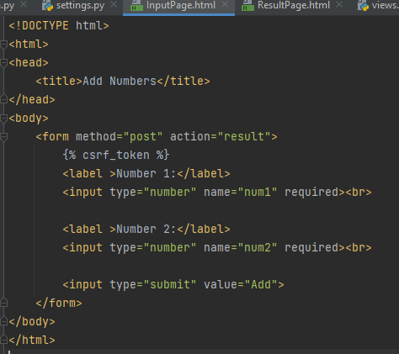

* **This is an HTML template for a form that takes two numbers as input.**
* **The form's action is set to 'result', which corresponds to the URL defined in** urls.py**.**

**2)**

**Views.py**

**In** views.py**, there are two view functions:**

* add_numbers**: This function renders the 'InputPage.html' template when the user accesses the root URL.**
* ResultPage**: This function is called when the form is submitted. It extracts the numbers from the POST request, performs addition, and renders the 'ResultPage.html' template with the result.**

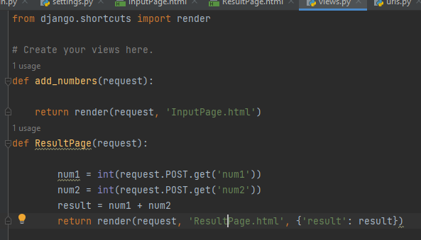

**3)ResultPage.html**

<p>The sum of Number 1 and Number 2 is: {{ result }}</p>**: This is a paragraph (**<p>**) element that contains dynamic content. The** {{ result }} **is a Django template variable, and its value will be dynamically replaced with the result of the addition operation calculated in the corresponding view function (**ResultPage**).**

* **For example, if the user input numbers 3 and 5, the rendered HTML will look like: "The sum of Number 1 and Number 2 is: 8".**

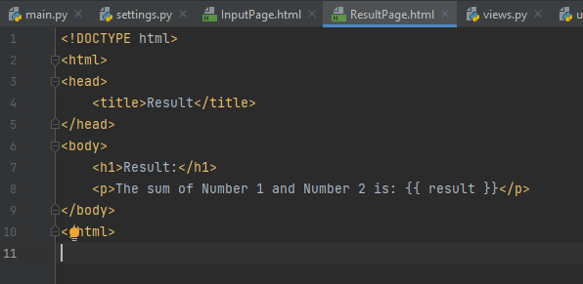

**4)**

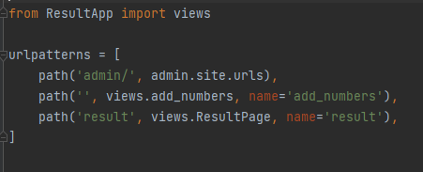

* **This code defines the URL patterns for your Django application.**
* **The root path ('/') is mapped to the** add_numbers **view, and the '/result' path is mapped to the** ResultPage **view.**

**OutPut**

This HTML template is designed to display the result of adding two numbers. It includes a heading indicating it's the result page and a paragraph that dynamically shows the sum of the numbers submitted through the form. The dynamic content ({{ result }}) is provided by the Django view when rendering this template.

